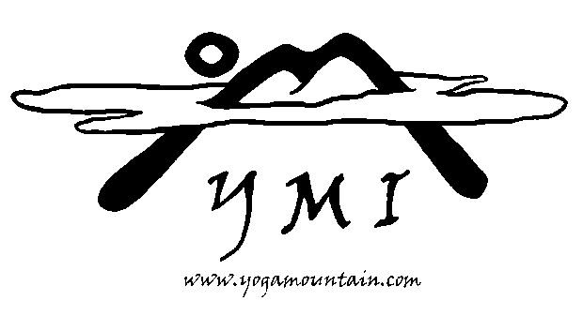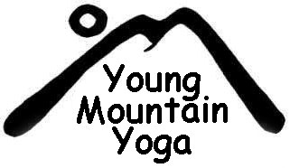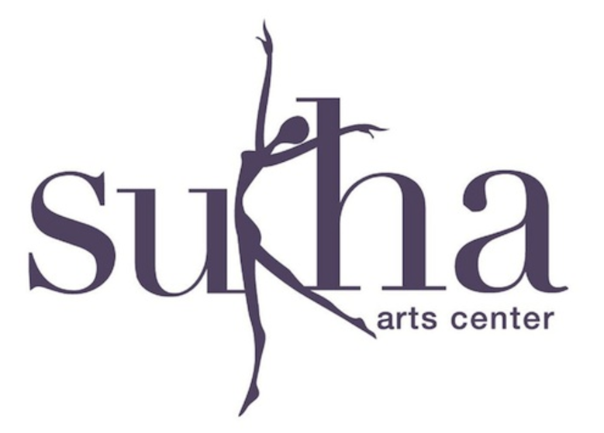
Yoga Mountain Inc. Presents:
Accelerated 200
Teacher Training Programs
Summer 2017
@ Sukha Arts Center
76 Schraalenburgh Road – Harrington Park – NJ www.sukhaarts.com 201.768.2455
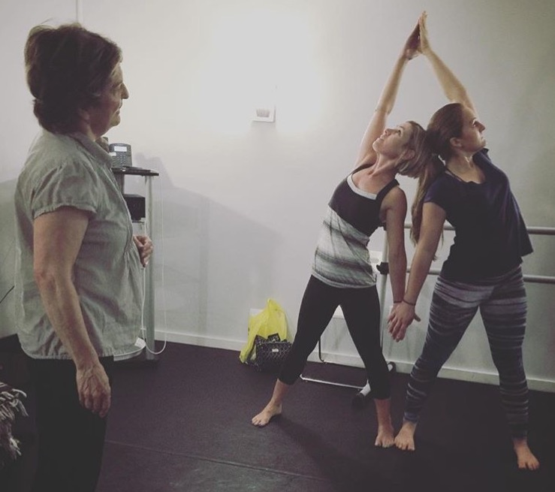

Finish Your Certification in two months!
We are all teachers at heart
Our Yoga Mountain certification program is designed to fire up your creative imagination and give you the confidence and tools you need to become an excellent inspired teacher.
Yoga Mountain has been certifying teachers since 1997 and is recognized as one of the oldest and most well established programs in the United States. The 200-hour and 300 hour/ Healing Yoga certification programs are approved by the National Yoga Alliance.

Program Schedule for Summer 2017
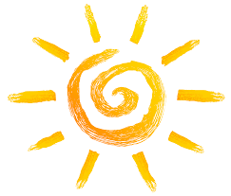
Session 1
June Dates
Weekdays will be Monday through Thursday 9:30-12:30
Week one: 6/5, 6/6, 6/7, and 6/8
Week two: 6/12, 6/13, 6/14, and 6/15
Week Three: 6/19, 6/20, 6/22, and 6/23
Week Four: 6/26, 6/27, 6/28, and 6/29
Weekends will be Saturday and Sunday 12:30 -6:30
Weekend one: Saturday June 10th and 11th
Weekend two: Saturday June 24th and 25th
July Dates
(overlaps with session two)
Weekdays will be Monday through Thursday 9:30-12:30
Week one: 7/5, 7/6
Week two: 7/10, 7/12, 7/13, and 7/14
Week Three: 7/17, 7/18, 7/19, and 7/20
Week Four: 7/ 24, 7/25, 7/26, and 7/27
Week five: 7/31
Weekends will be Saturday and Sunday 12:30 -6:30
Weekend one: July 8th and 9th
Weekend two: July 22nd and 23rd

Session 2
July Dates
(overlaps with session two)
Weekdays will be Monday through Thursday 9:30-12:30
Week one: 7/5, 7/6
Week two: 7/10, 7/12, 7/13, and 7/14
Week Three: 7/17, 7/18, 7/19, and 7/20
Week Four: 7/ 24, 7/25, 7/26, and 7/27
Week five: 7/31
Weekends will be Saturday and Sunday 12:30 -6:30
Weekend one: July 8th and 9th
Weekend two: July 22nd and 23rd

August Dates
Weekdays will be Monday through Thursday 9:30-12:30
Week one: 8/1, 8/2, 8/3, and 8/4
Week two: 8/7, 8/8, 8/9, and 8/10
Week Three: 8/14, 8/15, 8/16, and 8/17
Week Four: 8/21, 8/22, 8/23, and 8/24
Week five: 8/28, 8/29, 8/30, and 8/31
Weekends will be Saturday and Sunday 12:30 -6:30
Weekend one: August 5th and 6th
Weekend two: August 19th and 20th

The program includes 180 hours in the classroom in order to graduate. If you have to miss you can attend classes from the other session, use hours that you have already accumulated OR extra assignments can be given to complete your hours.

The other 20 hours include elective hours. This includes Yoga classes and workshops that are taken outside the certification program. You may include any Yoga classes taken at Sukha.
Benefits of the new program include:
Accelerated Program: Get your Yoga Alliance 200 hr certification over the summer! Our program consists of two sessions. The first is June and July and the Second is July and August (the sessions will overlap for one month!).
Receive instruction: from expert yogis who were personally trained through Yoga Mountain with years of experience in the practice and the business of Yoga.
Practicum: Hands on training. Students learn by practicing alongside, observing and assisting our instructors.
It doesn’t end there… even after your training is complete you have the option to come back and take our Weekly Workshops and Weekend Intensives at a reduced price!
*As listed in our fees section your tuition must be paid in full in order to graduate.

Each student will:
-Learn the energy chakra system of yoga
-Master 45 asanas and explore various forms of vinyasa
-Become adept at designing a class and sequencing
-Understand the anatomy of Yoga
-Refine your teaching skills
-Gain a firm grounding in the philosophy of yoga
-Explore the practice of pranayama (breath) and how to teach it
-Practice meditation
-Learn adaptive yoga and restorative yoga
-Have fun with partner yoga
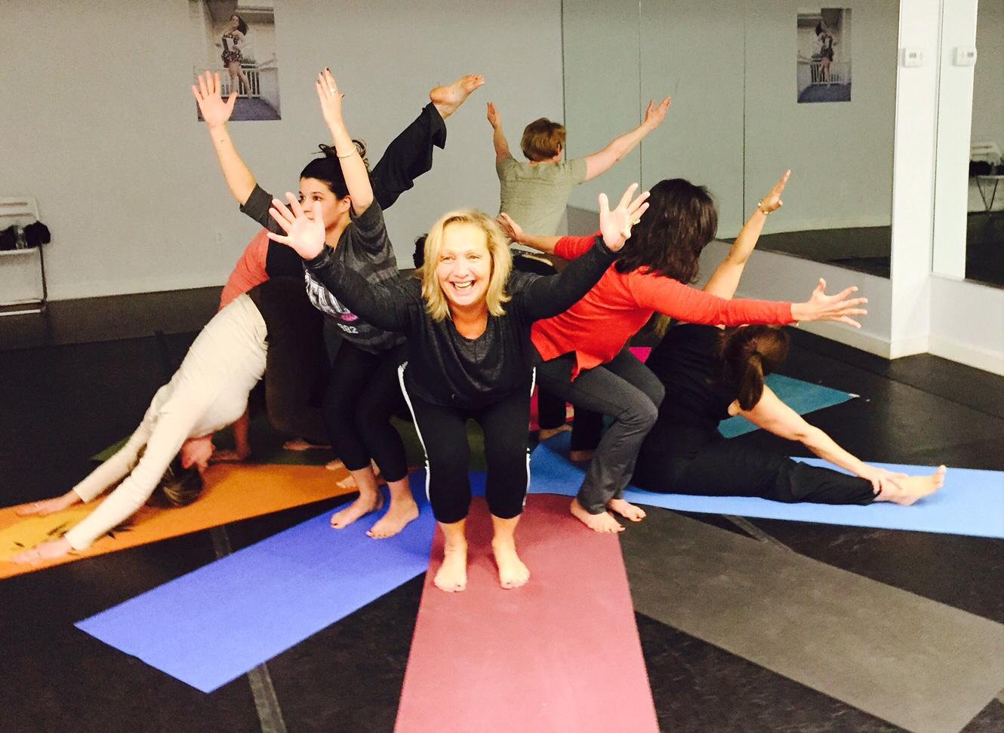
-Learn the basics of aerial yoga

The Fees

200 Hour Yoga Teacher Certification Program $3300.00
Payment plan available
Contact Gina at Sukha, 201.768.2455

Student Perks:
Students Enjoy: Free classes at hosting studio for duration of program

About Yoga Mountain

For the past 20+ years Yoga Mountain has offered 200 and 300 hr/Holistic Healing Yoga Teacher Certification programs. Our affiliate, Young Mountain Yoga, offers a 95-hour certification program that teaches adults how to share yoga with children and teens. Our certification programs deepen your knowledge of yogic philosophy, anatomy and the physical practice of yoga. Giving you the knowledge and skills to pass along your love of yoga to your students and those around you. Gail Walsh, the founder and director of Yoga Mountain, has certified Over 400 yoga teachers since 1997.

Our training is centered on the understanding of mindfulness, alertness, compassion, and commitment; these are essential to the practice of yoga. At Yoga Mountain, we explore them all — along with asana, pranayama and meditation — in an open-minded, adventurous spirit. Our programs stand above the rest with our breadth of perspective, hands-on attention to the needs of the individual, and roster of expert teachers personally trained by Yoga Mountain. After finishing your training not only will you have developed your knowledge and skills as a yoga teacher, you will also be part of the Yoga Mountain Community.

The Faculty
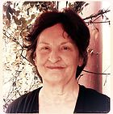
Gail Bentley Walsh Founder and Director
Gail Bentley Walsh is the Founder and Director of Yoga Mountain Inc. and of Young Mountain Yoga. She is an E-RYT (Experienced Registered Yoga Teacher), a Yoga Therapist* (pending) with the International Association of Yoga Therapists (IAYT) and an RCYT (Registered Children’s Yoga Teacher). Her Yoga Mountain Yoga Teacher Certification programs have been ongoing since 1994, approved by the National Yoga Alliance and recognized as one of the oldest and most established programs in the United States. Gail has not only trained hundreds of students in her 200 and (300) 500-hour yoga teacher certification programs.
Gail has been teaching yoga in public, private and special education schools since 1989 — offering training and workshops for K-12 educators including teachers, teaching assistants, health-care workers, social workers, psychologists, clinicians and school administrators. She is an expert when it comes to K-12 education involving the science of yoga. Gail designed her accredited graduate course for teaching yoga in the classroom with an emphasis on health, relaxation, self-confidence and self-regulation. Teaching Self-Regulation to Improve Academic Performance and Interpersonal Relations. Author and illustrator of “Yoga in the Classroom.”
Contact: gailbentleywalsh@gmail.com

*The yoga therapy components of my teaching are based on my [non-YAR credential or other qualification], not derived from my status as an [RYT/E-RYT] with Yoga Alliance Registry.

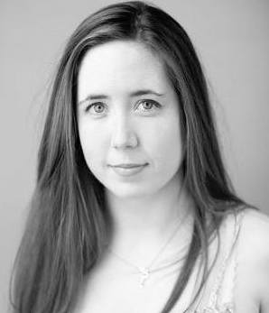
Abigail Hammond Assistant Director
Abigail has practiced yoga for many years, however it did not became an influential part of her life until a few years ago. At the time she was working with children who had suffered from trauma and her work environment was very stressful and draining. She began a regular yoga practice for herself, which gave her more energy, allowed her to self-regulate, manage her stress and become a more centered and mindful person. She realized she couldn't keep these benefits to herself and decided she to share yoga’s benefits with those around her!
She began her training by taking a 95 hr Children and Teen certification program through Young Mountain in 2014. Afterwards she began to teach many children's classes. She went on to receive her 200 and 500 HR through Yoga Mountain under the guidance of Gail Walsh, Janet Vignola and Ronda Lam. Currently. While Abigail specializes in teaching yoga to children, she also has experience teaching adult vinyasa and restorative classes.
​
Contact: abigailhammond4@gmail.com

Timetable: Each level will end with a Weekend intensive

Level One
Philosophy: please research and journal about these topics; they will be discussed further in class
samtosha/contentment; ahimsa/non-harming; sthairya/ Stability; and Sukha/ease or sweetness.

Anatomy: Skeletal and muscular System

Poses: salutation to the sun, Mountain, child’s pose, cat/dog, tree, cobra, locust, bow, shoulder stand, plough, fish, down dog, upward dog, spinal twist, bridge, forward bend (standing and seated), triangle, zazen, proud warrior, easy seated pose, adepts pose. Familiarize yourself with the sanskrit names.

Reading Assignments:
-Walsh - Yoga in the Classroom: Pages 1-32
-Long - The Key Muscles of Yoga - Chapters 1-7
-Judith - The Wheels of Life - Intro & Chakra 1 and 2
-Desikachar - The Heart of Yoga - Intro and Chapters 1-5
Level Two
Philosophy: please research and journal about these topics; they will be discussed further in class
avidya/ spiritual ignorance and maya (assignments will be given out for philosophy presentations)

Anatomy: circulatory and respiratory systems

Poses: Salutation to the Moon; Squat, willow, pigeon, stork, standing pyramid, seated head to knee, eagle, wheel, head stand, camel, rabbit, standing stick, low lunge, staff pose, lotus, boat, wide leg forward bend standing and seated. Be prepared to lead us. Familiarize yourself with the Sanskrit names.

Reading Assignment
-Desikachar - The Heart of Yoga - Chapters 6-12
-Long - The Key Muscles of Yoga - Chapters 8-16
-Benson - Relaxation Response - Full Reading
-Judith - The Wheels of Life - Chakra 3 & 4

Level Three
Philosophy: please research and journal about these topics; they will be discussed further in class
samskara/indelible imprints; the three gunas/quality, strand; yin/yang; Shiva and Shakti.

Anatomy: Balance and Movement (inner ear and sight)

Poses: Salutation to the earth; warrior series, warrior spinal twist, Crow, conqueror’s pose, half-moon, King Dancer, scorpion, Fire log pose, hand stand, eight angle pose, standing split,

Reading Assignment:
Desikachar - The Heart of Yoga - Chapter 1 of Yoga Sutras (pgs. 149-183)
Judith - The Wheels of Life - Chakra 5 & 6
Long - The Key Muscles of Yoga - Chapters 17-26
McKenzie - Heal Your Own Back

Level Four
Philosophy: please research and journal about these topics; they will be discussed further in class
The Eightfold Path and the Koshas

Anatomy: Nervous and endocrine system

Poses: Vinyasa; Erich Schiffman standing flow series restorative poses, ashtanga flow series, and Bikram

Reading Assignment
• Judith - The Wheels of Life - Chakra 7

